PHASE 6
PROJECT TESTING
INTRODUCTION:
TEAM ID : SWTID-2026-6039
TEAM LEADER: Teja sri P
MAIL ID : tejasri28122006@gmail.com
Team members:
NAME: | MAIL ID:
Siyamala M | Shyamalamurugan61@gmail.com
Bhavani L | bhavanilakshmanan95979@gmail.com
Siva sakthi M | sivashakthi5873@gmail.com

the project documentation states that the REST APIs can be tested using Postman or Thunder Client. Thte supplied screenshots are included below as testing evidence.

Register API
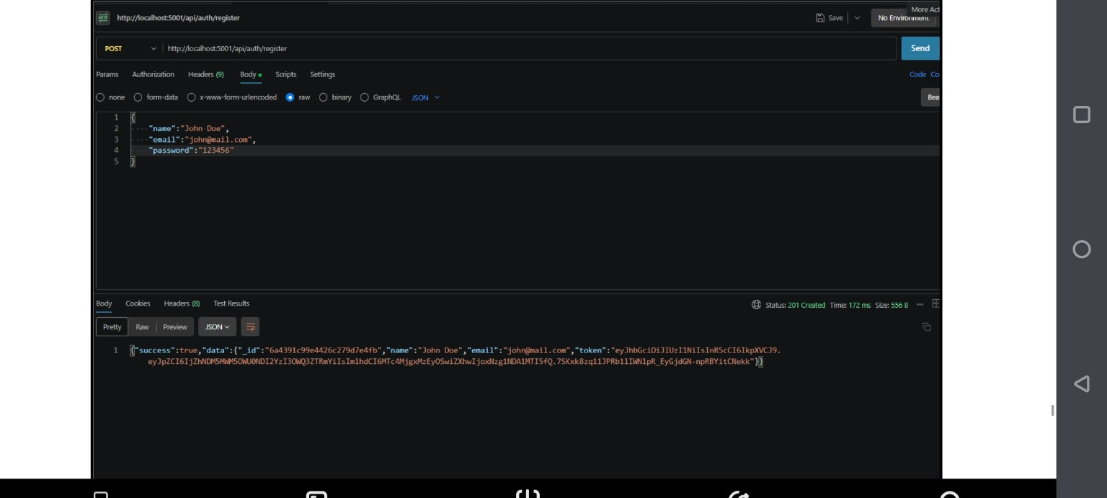
Register API — HTTP 201 Created

Weather API
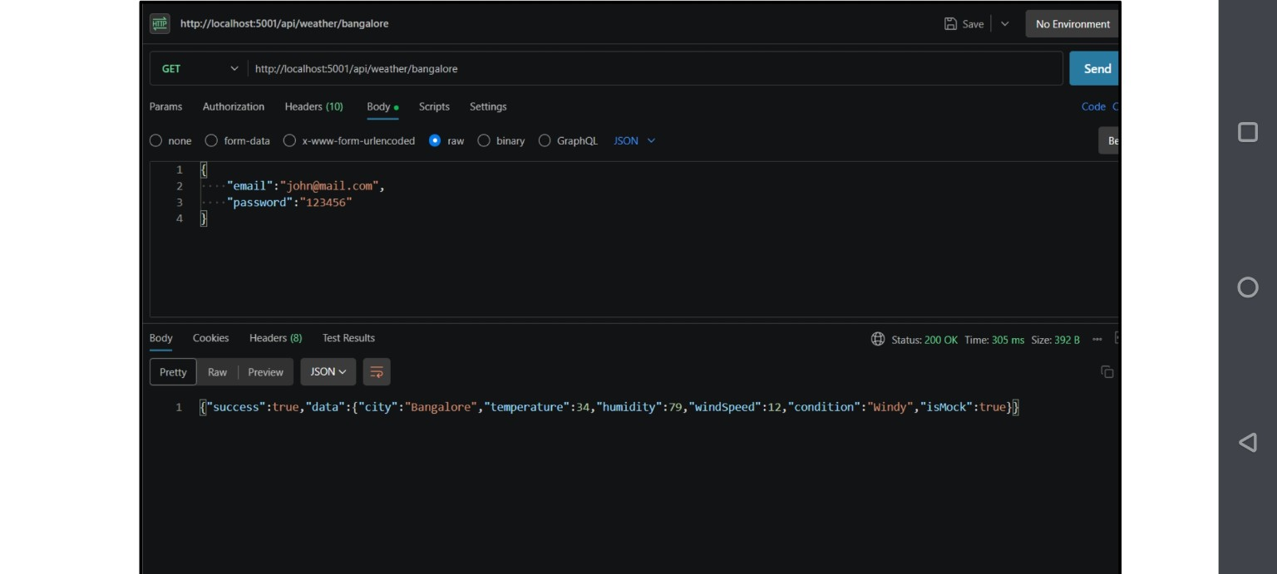
Weather API — HTTP 200 OK

Recommendation API
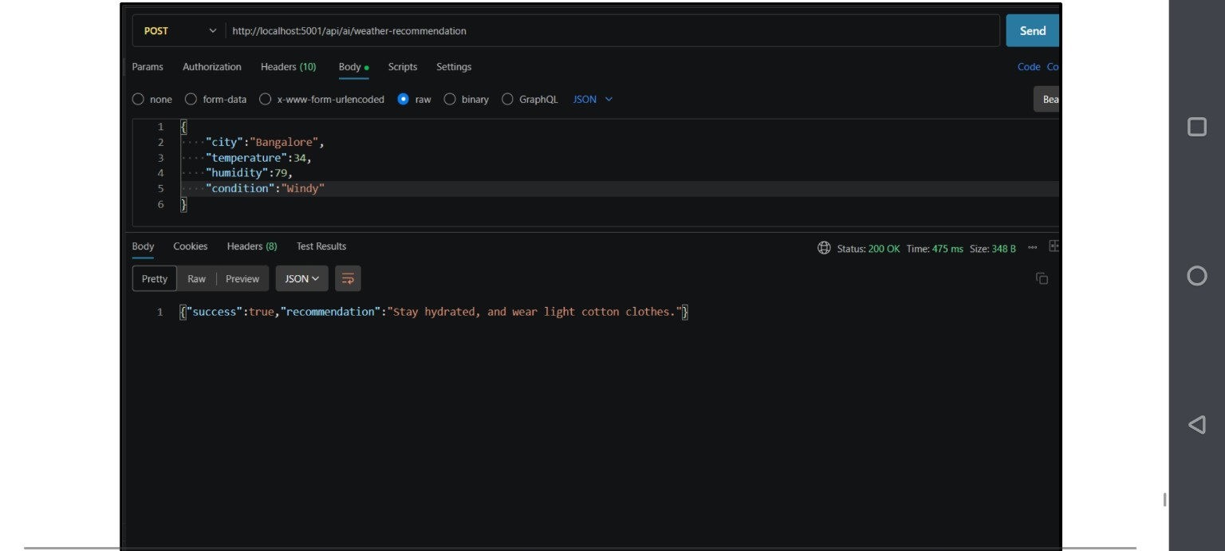
Weather Recommendation API — HTTP 200 OK
Testing result: the supplied screenshots show successful API responses for registration, weather retrieval and weather recommendation. The original documentation also lists Login API testing.

